PGI practical

Start of Block: Introduction

Introduction 2025 ESSGN Workshop - Polygenic prediction tutorial In this practical, we will first learn to navigate the Linux environment. Then, we will construct polygenic indexes (PGI) from SNP data and GWAS results using two different methods: Clumping and Thresholding (C+T) and SBayesR. We will then perform a polygenic prediction analysis in R. You are encouraged to work together in groups of two to help each other with the tasks. In each task you will be asked to work out a solution to a problem and share your solution using this questionnaire. There is more than one solution to some of these tasks and you can use whatever method works best for you. This tutorial assumes that you have already followed the instructions in the PGI practical preparation document. If not, please complete those steps before continuing.

End of Block: Introduction

Start of Block: Part 1: Linux

Part 1: Intro to Linux
To get started, open Ubuntu (Windows) or Terminal (MacOS / Linux), enter bash. We do this to make sure we are all working in the same shell. The shell is the command interpreter between you and the OS. When you enter a command on the screen, the shell interprets the command and calls the program you want. There are a number of shells available for Linux (e.g. tsch, zsh, bash, etc.).

Some basic information about interacting with the shell:
- We are working with a command line interface, i.e. you can only operate using the keyboard. You cannot click on things using the mouse.
- You must press ENTER for the command to be interpreted.
- Ways of correcting typing mistakes:
  - Erase one character at a time: BACKSPACE or DELETE
  - Back up a word at a time: CTRL + W
  - Back up to the beginning of the command line: CTRL + U
  - After you press ENTER, it is too late to correct a mistake: You must either wait for the command to run to completion or abort execution of the program (CTRL + C).
  - To repeat a previous command under bash, press the UP ARROW key. Each time you press this key, the shell displays an earlier command line.

Linux filesystem
The Linux filesystem is hierarchical (called a tree). It consists of a set of connected files. This structure allows you to organize files so you can easily find any particular one. On a standard Linux system, each user starts with one directory, to which the user can add subdirectories to any desired level.
Every file has a pathname, which is a trail from a directory through part of the directory hierarchy to an ordinary file or a directory.
The root directory of the filesystem hierarchy does not have a name referred to as the root directory represented by a / (slash) standing alone or at the left end of a pathname.
An absolute pathname starts with a slash (/), which represents the root directory continues, tracing a path through all intermediate directories, to the file identified by the pathname.
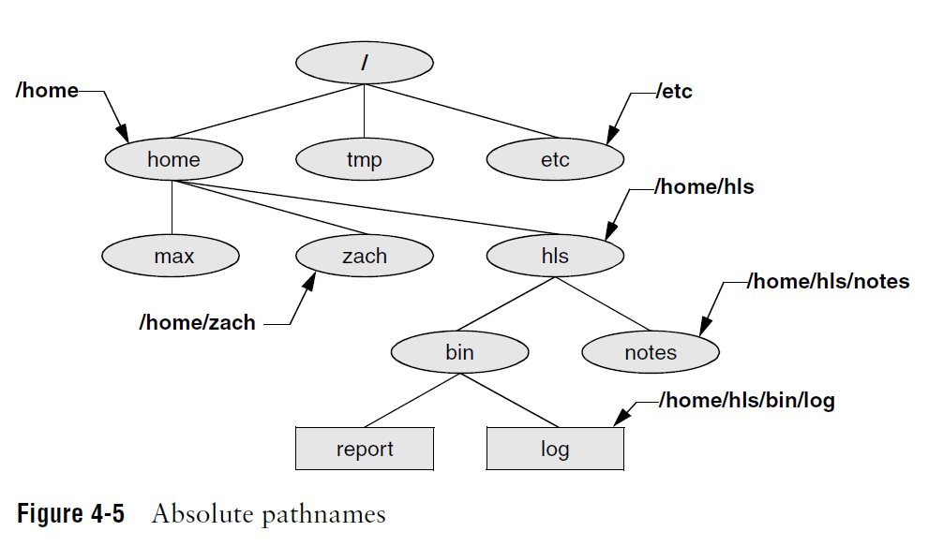

A relative pathname traces a path from the working directory to a file or directory.
The command cd followed by an absolute or relative pathname takes you to the directory that pathname represents.
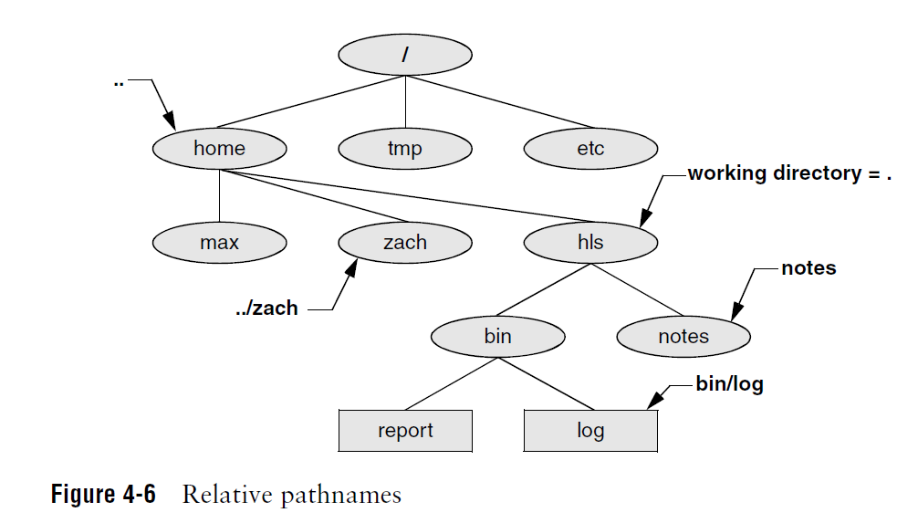

In Linux systems, variables are denoted by the "$" sign. Variables can be user-defined, but there are also variables called environment variables. These are dynamic variables available by default to the shell and its child processes. $HOME is one of these. If you enter the command echo $HOME, you will see that the value it carries is your home directory absolute pathname. So instead of /home/username, you can always use $HOME.

You can see all of your environment variables by running the command printenv .

Q1.1: Try going to the directory where the 1000 Genomes genotype data is stored. What is the absolute pathname?
________________________________________________________________
________________________________________________________________

Q1.2: Now go to the directory where gctb is stored from where you are using the relative pathname. What is the command you use?
________________________________________________________________
________________________________________________________________

Q1.1 Answer: $HOME/PGI_practical/data/original/genotypes/

Q1.2 Answer: cd ../../../bin

Basic commands
On the command line each sequence of nonblank characters is called a token. An argument is a token, such as a filename, string of text, number, or other object that a command acts on. An option is an argument that modifies the effects of a command.

You can frequently specify more than one option, modifying the command in several different ways. Most commands require you to prefix options with a single hyphen (-), some commands use double hyphen (--). You can see the possible options for a command using --help after the command, (e.g. pwd --help)

Here are some basic Linux commands:
pwd : Displays current directory
mkdir : Creates directory echo: copies the command line to the screen ls : lists the names of files in the current directory.
cat : displays a text file
rm : deletes a file
cp : copies a file
mv : changes the name of a file
grep : searches for a string in a file
wc : count the number of words/lines in a file
head: displays the beginning of a file tail: displays the end of a file
sort : displays the lines of a file in order
uniq: Removes adjacent duplicate lines (file has to be sorted!)
gzip, gunzip : Compress, decompress files with .gz extension.

When you run these commands, the output (if there is one, e.g. with the head command) is by default printed on the screen. You can also redirect the output into a file by using the > sign followed by a file name. For example, head inputfile > outputfile will write the first ten lines of inputfile into outputfile. It is important to be careful that input and output file names are always different. Otherwise you'll end up with a blank file because the first action the shell takes when it sees the redirection symbol (>) is to remove the contents of the output file.

Q1.3 To construct the PGIs, we will be using the latest GWAS summary statistics for body height from Yengo et al. (2022).
You have already downloaded these (GIANT_HEIGHT_YENGO_2022_GWAS_SUMMARY_STATS_EUR.gz ). Decompress this file. What command did you use?
________________________________________________________________
________________________________________________________________
________________________________________________________________

Q1.4 Display the contents of the ReadMe file.
________________________________________________________________
________________________________________________________________
________________________________________________________________

Q1.5: Display the first 10 lines of the GWAS summary statistics.
________________________________________________________________
________________________________________________________________
________________________________________________________________

Q1.6: How many variants are included in the GWAS?
________________________________________________________________

Q1.3 Answer:
cd ../data/original/sumstats/
gunzip GIANT_HEIGHT_YENGO_2022_GWAS_SUMMARY_STATS_EUR.gz

Q1.4 Answer: cat Readme_Yengo_et_al_2022_Nature.txt

Q1.5 Answer: head GIANT_HEIGHT_YENGO_2022_GWAS_SUMMARY_STATS_EUR

Q1.6 Answer: The command below gives you the number of lines in the file. Subtract 1 for the header, 1373020 variants.
wc -l GIANT_HEIGHT_YENGO_2022_GWAS_SUMMARY_STATS_EUR

End of Block: Part 1: Linux

Start of Block: Part 2: Clumping and Thresholding

Part 2: Clumping and Thresholding (C+T)
The first thing we need to do is to get a list of approximately independent variants. We will do this by "clumping" the summary statistics as implemented in plink2. The plink2 clumping approach takes the GWAS results as starting point. Clumps (i.e. groups of SNPs in LD) are formed around central ‘index SNPs’ which, by default, must have a P-value < 10-4. This threshold can be changed with the --clump-p1 option. Index SNPs are chosen greedily starting with the lowest P-value. SNPs that meet the --clump-p1 threshold, but have already been assigned to another clump, do not form their own clump unless --clump-best is specified. SNPs that are less than 250,000 base pairs away from an index SNP, that have and r2 larger than 0.5 with that index SNP, and have an association P-value < 0.01 are assigned to that index variant's clump (unless they have already been assigned to another clump). These three thresholds can be changed with --clump-kb, --clump-r2, and --clump-p2 respectively.

By default, SNP IDs are expected to be in the column of the input file that has ‘SNP’ as header. You can change this with the --clump-snp-field flag. By default, P-values are expected to be in the ‘P’ column. This can be changed using the --clump-field option.

Clumping is a greedy algorithm that reduces the full set of SNPs to a set of ‘clumps’, where each clump is represented by one index SNP, the SNP that has the strongest association with the outcome among all SNPs in that clump.

Reference data

The correlation between the SNPs is calculated using a reference genotype dataset. These genotypes should be representative of the GWAS sample in terms of genetic ancestry. Therefore, we will use the EUR-genetic-ancestry samples from the 1000 Genomes Phase 3 data which you have already downloaded into $HOME/PGI_practical/data/original/genotypes.
all_phase3.pgen.zst
all_phase3.pvar.zst
all_phase3.psam

The downloaded files are compressed, so we first need to decompress them. We can do this using plink2. To call plink2, we need to specify its pathname, which may be somewhat cumbersome. Instead, if we first run the command below, the $HOME/PGI_practical/bin directory will be added to the $PATH environment variable. The $PATH variable is a list of one or more directory names separated by colon (:) characters. When a command name is specified by the user, the system searches through $PATH, examining each directory from left to right in the list, looking for a filename that matches the command name. So it will find plink2 even if we don't refer to it using its pathname.

export PATH="$HOME/PGI_practical/bin/:$PATH"

If you want this to work every time you work on bash (rather than only the current instance), you need to also run:

echo 'export PATH="$HOME/PGI_practical/bin/:$PATH"' >> $HOME/.bashrc

Now let's go into $HOME/PGI_practical/data/original/genotypes and decompress the files: plink2 --zst-decompress all_phase3.pgen.zst all_phase3.pgen plink2 --zst-decompress all_phase3.pvar.zst all_phase3.pvar
(NOTE: The .psam file is not compressed, so no need to decompress that one)

Take a look at the first lines of the all_phase3.psam file by running:
head all_phase3.psam

It would be good to create a directory where we will write all the processed data at this point: mkdir $HOME/PGI_practical/data/processed

Let's say we want to obtain the number of women in the sample. Women are denoted by 2 in the SEX column. We can write the IID's of women into a file using the awk command:

awk -F"\t" ' NR>1 && $4=="2" {print $1}' all_phase3.psam > ../../processed/1kG_ph3_women.ids and then run
wc -l ../../processed/1kG_ph3_women.ids
Here -F"\t" denotes that the input file delimiter is tab, NR>1 skips the first line (header), "&&" is the logical "and" operator ("||" is the same for "or"), $4=="2" selects the lines for which the fourth field is equal to 2 and {print $1} prints the first field (IID).

Useful tip: We can also combine these two commands using the pipe ( | ) operator: awk -F"\t" 'NR>1 && $4=="2" {print $1}' all_phase3.psam | wc -l The pipe re-directs the output of the first command into the input of the next one. This way, we can get the number of women without creating a file with the IDs. Only the output of the last command is printed on the screen because it is not redirected into a new command or a file. This is not specific to awk or wc, it works with all Linux utilities. You can combine as many commands as you like using pipes.

Q2.1: We need the list of individuals with EUR-genetic-ancestry so that we use only these individuals to estimate LD when clumping the GWAS results (since the discovery sample of the GWAS that we downloaded is also EUR-genetic-ancestry). Write the IID's of EUR-genetic-ancestry individuals into a file named 1kG_ph3_EUR.ids in $HOME/PGI_practical/data/processed
________________________________________________________________
________________________________________________________________

Q2.2: How many EUR samples do we have?
________________________________________________________________

Q2.1 Answer:
awk -F"\t" ' NR>1 && $5=="EUR" {print $1}' all_phase3.ps am > ../../processed/1kG_ph3_EUR.ids

Q2.2 Answer: The following command gives 503 EUR samples
wc -l ../../processed/1kG_ph3_EUR.ids

Ref data QC

Now we will restrict the variants to those with a minor allele frequency of at least 0.01 and missingness less than 5%, and the sample to unrelated individuals with EUR ancestry with genotype missingness less than 5%. The variant filters are needed to have a good quality set of variants for which we can estimate LD reliably. The sample missingness filter is needed to drop samples for whom something went wrong in genotyping (which would lead to high missingness). We drop related individuals because relatedness would lead to unrepresentative the LD estimates. Note that the data that we are using here is sequence data, which may not always be the case. If you are using imputed data, you may also want to drop variants with low imputation accuracy.

Let's create a new directory called "genotypes" in "$HOME/PGI_practical/data/processed" and write these filtered files there.

mkdir $HOME/PGI_practical/data/processed/genotypes

plink2 --pfile all_phase3 \
--keep $HOME/PGI_practical/data/processed/1kG_ph3_EUR.ids \
--maf 0.01 \
--geno 0.05 \
--mind 0.05 \
--max-alleles 2 \
--rm-dup force-first \
--set-missing-var-ids @:# \
--chr 1-22 \
--king-cutoff 0.025 \
--make-pgen \
--out $HOME/PGI_practical/data/processed/genotypes/1kG_ph3_EUR

The "\"s at the end of the lines tells the shell that the command is not finished. This way, you can split your command into multiple lines, which makes it more legible.
--keep restricts the sample to individuals in the given list.
--maf 0.01 restricts the variants to those with MAF>0.01
--geno 0.05 restricts the variants to those with missingness less than 5%
--mind 0.05 restricts the sample to those with missingness less than 5%
--max-alleles 2 restricts the variants to biallelic variants to avoid problems during clumping
--chr 1-22 restricts the variants to autosomes.
--rm-dup force-first flag is needed to handle variants with duplicate IDs (which tend to create problems), keeping only the first occurrence.
--set-missing-var-ids @:# sets the missing variant ID's (coded ".") to "chromosome : base pair position". This is needed because "."s are perceived as duplicate IDs by plink, leading to problems later on.
--king-cutoff 0.025 Drops one individual from each pair with a KING relatedness coefficient larger than 0.025.
--make-pgen tells plink2 to write the output into a pgen format file (same as the input format). --out is the output file name.

Q2.3 How many variants were there before the filters? How many after the filters?
- Variants before filters __________________________________________________
- Variants after filters __________________________________________________
- Samples before filters __________________________________________________
- Samples after filters __________________________________________________

Q2.3 Answer: Check the log file:
cat $HOME/PGI_practical/data/processed/genotypes/1kG_ph3_EUR.log
84805772 variants and 2504 samples before filters, 9586749 variants and 495 samples after filters

Q2.4: We want to clump the GWAS summary statistics using an r2 cutoff of 0.3, a distance cutoff of 1Mb and a P-value cutoff of 0.5. We need to run the following plink command with a few additional flags. Can you fill in the arguments for these flags? (Note: you need to create the $HOME/PGI_practical/data/processed/sumstats directory first)

plink2 --pfile $HOME/PGI_practical/data/processed/genotypes/1kG_ph3_EUR \
--clump $HOME/PGI_practical/data/original/sumstats/GIANT_HEIGHT_YENGO_2022_GWAS_SUMMARY_STATS_EUR \
--out $HOME/PGI_practical/data/processed/sumstats/HEIGHT_EUR_p5e-1_rsq30 \
- --clump-snp-field _____________________________________________
- --clump-p1 __________________________________________________
- --clump-p2 __________________________________________________
- --clump-r2 __________________________________________________
- --clump-kb __________________________________________________

Q2.4 Answer: --clump-snp-field RSID --clump-p1 0.5 --clump-p2 0.5 --clump-r2 0.3 --clump-kb 1000

Q2.5: If you run the command, plink will give you an error that line 3049 has fewer tokens than expected. Look at line 3049 by running
head -3049 $HOME/PGI_practical/data/original/sumstats/GIANT_HEIGHT_YENGO_2022_GWAS_SUMMARY_STATS_EUR | tail -1

You will see that some columns are just left empty, which is leading to problems. You can fix this by putting NA in these columns. Run
sed ‘s/\t\t/\tNA\t/g' $HOME/PGI_practical/data/original/sumstats/GIANT_HEIGHT_YENGO_2022_GWAS_SUMMARY_STATS_EUR > $HOME/PGI_practical/data/processed/sumstats/GIANT_HEIGHT_YENGO_2022_GWAS_SUMMARY_STATS_EUR

sed is a text editing utility. The instructions to sed are contained within the single quotes. "s" means replace, so it will replace the string contained within the next two slashes (\t\t) with the string coming after (before the third slash, i.e. \tNA\t ). The general structure is sed 's/string_to_replace/string_to_replace_with/g' . "g" tells sed to keep looking until the end of the line (i.e. don't stop after doing one replacement). sed can do things other than replace strings, but we are not going to get into those here.

The command above replaces all double tabs (\t\t) with tab NA tab (\tNA\t). Now rerun the clump command with the fixed file. How many clumps were made?
________________________________________________________________

Q2.5 Answer: 179791 clumps

End of Block: Part 2: Clumping and Thresholding

Start of Block: Part 3: Making PGIs

Part 3: Making the PGI
Take a look at the HEIGHT_EUR_p5e-1_rsq30.clumps file. The index SNP for each clump is listed in the ID field. We need to extract those SNPs:
cd $HOME/PGI_practical/data/processed/sumstats/
awk 'NR>1{print $3}' HEIGHT_EUR_p5e-1_rsq30.clumps > HEIGHT_EUR_p5e-1_rsq30.snps

Now we can make the PGIs. We will make the PGIs for the same sample we used to estimate LD (but before the QC filters). Of course, in reality, this does not have to be the case, i.e. the LD reference dataset does not need to be the same as the validation sample. We can make the PGI using the following command (note: create a $HOME/PGI_practical/data/processed/PGI directory first)

plink2 --pfile $HOME/PGI_practical/data/original/genotypes/all_phase3 --keep $HOME/PGI_practical/data/processed/1kG_ph3_EUR.ids --extract $HOME/PGI_practical/data/processed/sumstats/HEIGHT_EUR_p5e-1_rsq30.snps --score $HOME/PGI_practical/data/processed/sumstats/GIANT_HEIGHT_YENGO_2022_GWAS_SUMMARY_STATS_EUR 2 5 8 --out $HOME/PGI_practical/data/processed/PGI/PGI_height_1kG_ph3_EUR_CT.p5e-1

In this command, --extract $HOME/PGI_practical/data/processed/sumstats/HEIGHT_EUR_p5e-1_rsq30.snps restricts the genotype data to the index SNPs we obtained as a result of clumping and thresholding, --score $HOME/PGI_practical/data/processed/sumstats/GIANT_HEIGHT_YENGO_2022_GWAS_SUMMARY_STATS_EUR 2 5 8 tells plink2 to get the weights from GIANT_HEIGHT_YENGO_2022_GWAS_SUMMARY_STATS_EUR, where the SNP identifier is in the 2nd, the effect allele is in the 5th and the effect size is in the 8th field.

Since we restricted the set of SNPs to those with P-values less than 0.5 while clumping, the resulting PGI includes only the index SNPs with P<0.5.

Take a look at PGI_height_1kG_ph3_EUR_CT.p5e-1.sscore. For each individual, the ALLELE_CT field shows the number of alleles across scored variants. The NAMED_ALLELE_DOSAGE_SUM is the sum of named allele dosages. The SCORE1_AVG field is the PGI.

Multiple P cutoffs

We may want to construct multiple PGIs with different P-value cutoffs. To do that, we do not need to create a different input file for each PGI. Plink provides an option to make multiple such PGIs with a single command.

We first need to create a "range" file that looks like:
S1 0.00 0.01
S2 0.00 0.20
S3 0.10 0.50

Here, the first column holds the range labels, the second column P-value lower bounds, and the third column the P-value upper bounds. So if we want four additional PGIs with P-value cutoffs 0.1, 0.001, 0.00001, and 5e-8 (i.e. genome-wide significance), our file will look like p5e-8 0.00 5e-8 p1e-5 0.00 1e-5 p1e-3 0.00 1e-3 p1e-1 0.00 1e-1

You can create this file by running the following command
echo -e "p5e-8 0.00 5e-8\np1e-5 0.00 1e-5\np1e-3 0.00 1e-3\np1e-1 0.00 1e-1" > range.txt

Here, \n means newline, -e enables interpretation of backslash escapes so that echo doesn't print \n but instead interprets its meaning and starts printing on a new line.

You need to use this file as an argument to the --q-score-range flag when running the scoring command. In addition to the range file, you need some additional arguments using the following syntax: --q-score-range <range file> <data file> [i] [j] ['header']
The <data file> is a file with variant IDs and a P-value column, [i] is the variant ID column number, [j] is the P-value column number, 'header' specifies that there is a header in the data file that needs to be skipped.

Q3.1: Finish the following command with the --q-score-range flag together with the correct arguments to create four additional PGIs with P-value cutoffs 0.1, 0.001, 0.00001, and 5e-8.

plink2 --pfile $HOME/PGI_practical/data/original/genotypes/all_phase3 \
--keep $HOME/PGI_practical/data/processed/1kG_ph3_EUR.ids \
--extract $HOME/PGI_practical/data/processed/sumstats/HEIGHT_EUR_p5e-1_rsq30.snps \
--score $HOME/PGI_practical/data/processed/sumstats/GIANT_HEIGHT_YENGO_2022_GWAS_SUMMARY_STATS_EUR 2 5 8 \
--out $HOME/PGI_practical/data/processed/PGI/PGI_height_1kG_ph3_EUR_CT \
________________________________________________________________
Q3.1 Answer:
--q-score-range range.txt /home/aokbay/PGI_practical/data/processed/sumstats/GIANT_HEIGHT_YENGO_2022_GWAS_SUMMARY_STATS_EUR 2 10 header

Q3.2: How many SNPs were used to make each PGI?
- P<0.5 __________________________________________________
- P<0.1__________________________________________________
- P<0.001 __________________________________________________
- P< 0.00001__________________________________________________
- P< 5e-8 __________________________________________________

Q3.2 Answer: Divide the allele count (ALLELE_CT column in each PGI file) by two:
P<.05: 179789
P<.01: 109301
P<1e-3: 42852
P<1e-5: 25003
P<5e-8: 16304

Discussion Question #1:
Before we build prediction a model ourselves, lets take a break to discuss a hypothetical example:
A researcher is investigating whether PGIs from a GWAS of ‘openness to experience’ (N=250,000) predicts whether individuals report being willing to attend a concert from the new heavy metal band “Phenotype Destruction” (N=2,000). They use a clumping method to test 5 p-value thresholds. They obtain the incremental-R2 of all PGIs, controlling for 10 ancestry-based principal components, sex, and the age of participants.
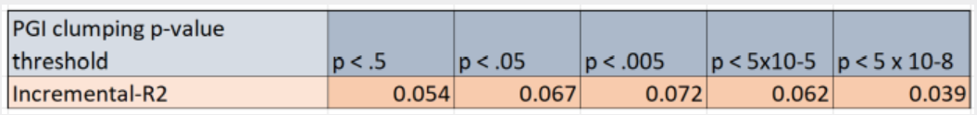
They see that the "best" PGI is the one with the P-value cutoff of 0.005. So they discard the remaining PGIs, and use this one to estimate the effect of the PGI on attending the concert. They report only this analysis in their study. Do you see a problem with this approach? What would you do differently?
________________________________________________________________

End of Block: Part 3: Making PGIs

Start of Block: Part 4: SBayesR

Part 4: SBayesR
Now we will try a Bayesian methodology, namely SBayesR, implemented in gctb software. Instead of including only a set of approximately independent SNPs that have association P-values less than a certain cutoff, Bayesian approaches adjust effect sizes for LD and include all (or nearly all) SNPs. Since SBayesR is computationally more intensive, we will restrict ourselves to chromosome 21.

In order to adjust effect sizes for LD, just like in the C+T approach, SBayesR needs pairwise correlation estimates for all SNPs on the same chromosome. However, Bayesian approaches are more sensitive to noise in LD estimates since what they are doing is not just deciding if a SNP is in or out by comparing the LD estimate to the chosen cutoff (as we do in C+T), but instead adjusting the effect size for LD. Therefore, they require precise LD estimates obtained from larger representative samples. Our 1kG EUR-genetic ancestry sample is not large enough for this purpose. We will instead be using the LD estimates obtained from UK Biobank that have been made available by the SBayesR folks (Lloyd-Jones et al.). You have already downloaded the chromosome 21 files into $HOME/PGI_practical/original/ref_data: ukbEURu_hm3_chr21_v3_50k.ldm.sparse.info ukbEURu_hm3_chr21_v3_50k.ldm.sparse.bin

Next, we need GWAS summary statistics in the format that SBayesR accepts, i.e.
SNP A1 A2 freq b se p N rs1001 A G 0.8493 0.0024 0.0055 0.6653 129850
rs1002 C G 0.0306 0.0034 0.0115 0.7659 129799
rs1003 A C 0.5128 0.0045 0.0038 0.2319 129830

Our sumstats look like this:
SNPID RSID CHR POS EFFECT_ALLELE OTHER_ALLELE EFFECT_ALLELE_FREQ BETA SE P N
1:566875:C:T rs2185539 1 566875 T C 0.00280 -0.0463156 0.0393 0.238128 537968 1:728951:C:T rs11240767 1 728951 T C 0.000356 0.167358 0.126 0.185025 85591

Using awk, we can easily re-format these sumstats:
awk -F"\t" 'NR==1{print "SNP", "A1", "A2", "freq", "b", "se", "p", "N"} NR>1{print $2,$5,$6,$7,$8,$9,$10,$11}' $HOME/PGI_practical/data/processed/sumstats/GIANT_HEIGHT_YENGO_2022_GWAS_SUMMARY_STATS_EUR > $HOME/PGI_practical/data/processed/sumstats/HEIGHT_SBayesRformat.txt

Here, NR==1 is a condition. It applies the command following it (printing the column headers) to only the first line. The next condition, NR>1, tells awk to apply the next command to second line and onwards. The command itself prints each field ($2 means second field) in the specified order.

SBayesR syntax The SBayesR syntax is as following:
gctb --sbayes R \
--ldm 1000G_eur_chr22.ldm.sparse \
--pi 0.95,0.02,0.02,0.01 \
--gamma 0.0,0.01,0.1,1 \
--gwas-summary sim_1.ma \
--chain-length 10000 \
--burn-in 2000 \
--out-freq 10 \
--out sim_1

In Bayesian methodologies, we need to have a prior on the distribution of effect sizes. SBayesR assumes a finite mixture of normal distributions as the prior. We will adopt what the SBayesR paper suggests as a good compromise between prediction accuracy and computational burden, namely a four-component mixture distribution.
The --pi option specifies the starting values for mixing probabilities, which will be estimated from the data. These should be specified as a comma separated string where the number of values defines the number of mixture components (the first value is reserved for the zero component). These must sum to 1.
--gamma speficies the scaling factors for the variance of the distribution of genetic effects for each distribution. Note that the vector length should match that in --pi.
--chain-length is the total number of iterations in MCMC
--burn-in is the number of iterations to be discarded.

Q4.1 First, move gctb executable to $HOME/PGI_practical/bin (which is in your $PATH) so that we can call it without specifying its full path (same trick we used for plink2): mv $HOME/PGI_practical/bin/gctb_2.5.2_Linux/gctb $HOME/PGI_practical/bin/ Now run the following SBayesR command together with the options below after filling in the arguments. Note that we would normally need more than 1000 iterations and more than 200 as burn-in (e.g. 10000 chain length, with 2000 burn-in), but we're opting for a short run here since it's just for demonstration purposes.
gctb --sbayes R \
--pi 0.95,0.02,0.02,0.01 \
--gamma 0.0,0.01,0.1,1 \
--chain-length 1000 \
--burn-in 200 \
--out $HOME/PGI_practical/data/processed/sumstats/HEIGHT_SBayesR_weights_chr21 \
- --ldm __________________________________________________
- --gwas-summary __________________________________________________

Q4.1 Answer:
--ldm $HOME/PGI_practical/data/original/ref_data/ukbEURu_hm3_chr21_v3_50k.ldm.sparse \ --gwas-summary $HOME/PGI_practical/data/processed/sumstats/HEIGHT_SBayesRformat.txt

Q4.2 If the command ran successfully, you will have obtained the following output files: HEIGHT_SBayesR_weights_chr21.snpRes: Text file of posterior statistics of SNP effects HEIGHT_SBayesR_weights_chr21.parRes: Text file of posterior statistics of key model parameters
HEIGHT_SBayesR_weights_chr21.covRes: Text file of posterior statistics of covariates HEIGHT_SBayesR_weights_chr21.badSNPlist: SNPs excluded from analysis

The adjusted SNP effects are in "HEIGHT_SBayesR_weights_chr21.snpRes", under the A1Effect column. Using these weights, write down and run the command to obtain a PGI using plink2 as we did before.
________________________________________________________________
________________________________________________________________
________________________________________________________________
________________________________________________________________
________________________________________________________________

Q4.2 Answer:

plink2 --pfile $HOME/PGI_practical/data/original/genotypes/all_phase3 \
--keep $HOME/PGI_practical/data/processed/1kG_ph3_EUR.ids \
--score $HOME/PGI_practical/data/processed/sumstats/HEIGHT_SBayesR_weights_chr21.snpRes 2 5 8 \
--out $HOME/PGI_practical/data/processed/PGI/PGI_height_1kG_ph3_EUR_SBayesR_chr21

Q4.3 This SBayesR PGI is based only on chromosome 21. It would be good to have a whole-genome SBayesR PGI that is comparable to the C+T PGIs that we made. Fortunately, the GIANT consortium have posted their SBayesR weights online, so we can use those to make a PGI. You have already downloaded these weights: GIANT_HEIGHT_YENGO_2022_PGS_WEIGHTS_EUR.gz Now use these weights to make a PGI. Write your code below.
________________________________________________________________
________________________________________________________________
________________________________________________________________
________________________________________________________________
________________________________________________________________

Q4.3 Answer: First, we need to decompress the weights file:
gunzip $HOME/PGI_practical/data/original/sumstats/GIANT_HEIGHT_YENGO_2022_PGS_WEIGHTS_EUR.gz

Next, let's check which columns the SNP identifier, effect allele and effect are in by viewing the first couple of lines. This is what the file looks like:
SNPID RSID CHR POS PGS_EFFECT_ALLELE PGS_WEIGHT PGS_OTHER_ALLELE PGS_POSTERIOR_STANDARD_ERROR
1:100000827:C:T rs6678176 1 100000827 T 7.32345681972927e-05 C 0.000538668120915509
1:100005477:A:G rs12069019 1 100005477 A 0.000128141335406009 G 0.000668259187757778

The SNP identifier (in rs-id format, because that is what our 1kG genotype data uses) is in column 2, effect allele in column 5, effect in column 6. So the plink command is:

plink2 --pfile $HOME/PGI_practical/data/original/genotypes/all_phase3 \
--keep $HOME/PGI_practical/data/processed/1kG_ph3_EUR.ids \
--score $HOME/PGI_practical/data/original/sumstats/GIANT_HEIGHT_YENGO_2022_PGS_WEIGHTS_EUR 2 5 6 \
--out $HOME/PGI_practical/data/processed/PGI/PGI_height_1kG_ph3_EUR_SBayesR

End of Block: Part 4: SBayesR

Start of Block: Part 5: Prediction

Part 5: Building a Prediction Model
Now we will use these PGIs to run some prediction analyses in R. First go into your PGI directory ($HOME/PGI_practical/data/processed/PGI). If you look at the header line of your PGI files, you will notice that they start with a comment (#) character. This will cause the IID field to be read as X.IID in R. The easiest way to handle this would be to change that now before we run R:
sed -i 's/#//' *.sscore

Here, the "-i" option tells sed to change the files in place rather than writing the output to another file. "*.sscore" means all files ending with that extension, meaning all our PGI files.
We have prepared a simulated phenotype for this tutorial, which you can download by running:
wget "https://www.dropbox.com/scl/fi/md6gt3arosndq5tvg1xq9/HEIGHT.pheno?rlkey=zvzwypdlnw0hljul1a694krj3&dl=1" -O HEIGHT.pheno
Now run R in the terminal by typing R and pressing Enter.
We will start by reading the PGI files into R. You can do that using the following command: df_PGI_p5e1 <- read.table("PGI_height_1kG_ph3_EUR_CT.p5e-1.sscore", header=T, comment.char="")
(NOTE: We removed the "-" from "5e-1" on the left-hand-side of the assignment because R does not allow "-"s in object names).
Now let's make a histogram of these PGI:
png('PGI_p5e-1_histogram.png', height=6, width=6, units='in', res=300)
hist(df_PGI_p5e1$SCORE1_AVG, breaks=30)
dev.off()
This will create a file "PGI_p5e-1_histogram.png" in your working directory.

Q5.1: What does the distribution look like? Read in the remaining PGI files, including the SBayesR PGI based on all chromosomes.
________________________________________________________________

Q5.1 Answer: The distribution looks normal (bell-shaped)

df_PGI_p1e1 <- read.table("PGI_height_1kG_ph3_EUR_CT.p1e-1.sscore", header=T, comment.char="")
df_PGI_p1e3 <- read.table("PGI_height_1kG_ph3_EUR_CT.p1e-3.sscore", header=T, comment.char="")
df_PGI_p1e5 <- read.table("PGI_height_1kG_ph3_EUR_CT.p1e-5.sscore", header=T, comment.char="")
df_PGI_p5e8 <- read.table("PGI_height_1kG_ph3_EUR_CT.p5e-8.sscore", header=T, comment.char="")
df_PGI_SbayesR <- read.table("PGI_height_1kG_ph3_EUR_SBayesR.sscore", header=T, comment.char="")

Q5.2 It is common to standardize the PGI to have mean zero and standard deviation one in order to interpret effect estimates in terms of “a one standard-deviation increase in PGI is expected to increase Y by β”. Standardize all PGIs using the scale function: df_PGI_p5e1$PGI_p5e1_std <- scale(df_PGI_p5e1$SCORE1_AVG)[, 1]

Do the same for the remaining PGIs.

Q5.2 Answer:
df_PGI_p1e1$PGI_p1e1_std <- scale(df_PGI_p1e1$SCORE1_AVG)[, 1] df_PGI_p1e1$PGI_p1e3_std <- scale(df_PGI_p1e3$SCORE1_AVG)[, 1] df_PGI_p1e1$PGI_p1e5_std <- scale(df_PGI_p1e5$SCORE1_AVG)[, 1] df_PGI_p1e1$PGI_p5e8_std <- scale(df_PGI_p5e8$SCORE1_AVG)[, 1] df_PGI_p1e1$PGI_SbayesR_std <- scale(df_PGI_SbayesR$SCORE1_AVG)[, 1]

Model
Read the phenotype file into R. The file also contains sex and 10 principal components: HEIGHT <- read.table("HEIGHT.pheno", header=T)

We want to merge this phenotype data frame (let's assume it's called HEIGHT) with the PGI data frames. To do that, you can run
df <- merge(HEIGHT, df_PGI_p5e1, by=c("IID"))
df <- merge(df, df_PGI_p1e1, by=c("IID"))
and so on.

We can now use ordinary least squares (OLS) to estimate a linear model, where we regress Height on sex and the PGI, with an intercept in the model. In R this can be done using the lm function (lm stands for linear model):
model_p5e1 <- lm(height ~ PGI_p5e1_std + sex, data=df)
Here, the variable to the left of the ~ is the outcome or response or dependent variable (Y) The variables to the right of the ~ are the explanatory or independent or predictor or regressor variables (X). data=df tells R that the variables being used in the analysis come from the data frame we called df. You can see the regression results by running
summary(model_p5e1)

Q5.3: Is the coefficient of PGI_p5e1_std statistically significant at the 1% level? How many centimeters increase in height is one standard deviation increase in PGI_p5e1 associated with?
________________________________________________________________

Q5.3 Answer: Yes, it's statistically significant at 1%. One SD increase in the PGI is associated with 8.1 cm increase in height.

Q5.4 The coefficient of the PGI is not a metric to evaluate the prediction performance that is normally used. A popular measure for continuous phenotypes is incremental-R2 : the increase in the coefficient of determination when the PGI is added to a regression with only control variables. This can be computed as below:
model_baseline <- lm(height ~ sex, data=df) summary(model_p5e1)$r.squared - summary(model_baseline)$r.squared

What is the incremental-R2 of the P<0.5 PGI (i.e., 5e1)?
________________________________________________________________

Q5.4 Answer: 55%

Q5.6 This incremental-R2 seems somewhat large. The reason, as you may have guessed, is that we have not controlled for the principal components. Even if your GWAS result are free from confounding due to population stratification, your PGI may still be correlated to the PCs (and thereby population structure) in your hold-out sample. Thus, not controlling for the lead PCs of the genetic data in your hold-out sample may cause the estimated coefficient for the PGI to be biased due to population stratification. Now let's obtain the incremental-R2 of the PGI when they are added to a model that controls for the first 10 PCs. Instead of typing the PCs one by one (model_baseline <- lm(height ~ sex + PC1 + PC2+ ...), you can do the following

PC <- paste0("PC", 1:10) PC <- paste0(PC, collapse="+")
model_baseline <- lm(paste0("height ~ sex +", PC), data=df)

The first line creates a vector (PC1,PC2,PC2,...,PC10). The second line converts that to the string "PC1+PC2+PC3+...+PC10". The last line pastes this string to the end of the model formula and runs the regression.

Fill in the new incremental-R2 for the .5 PGI (5e1) below:
________________________________________________________________

Q5.6 Answer: 33%

Confidence intervals

It is also informative to report a 95% confidence interval for the incremental-R2. This is usually done by boostrapping. First, define a function that resamples the sample with replacement and outputs incremental-R2 from that sample:
bs_func <- function(s,PGI){
#set seed number
set.seed(s)
# draw indexes for resampling (with replacement)
BOOT_IN = sample(1:nrow(df), nrow(df), replace=TRUE)
# compute incremental R2 given the drawn indexes and PGI.
summary(lm(paste0("height ~ sex +", PGI, "+", PC), df[BOOT_IN,]))$r.squared - summary(lm(paste0("height ~ sex + ", PC), df[BOOT_IN,]))$r.squared
}

Now let's bootstrap the sample 100 times. We repeat applying the function 100 times and get a boostrapped distribution of incremental-R2 in a vector
rep = 1000
BOOT_p5e1_std = sapply(1:rep, bs_func, "PGI_p5e1_std")

Sort the vector and simply get a percentile-based CI:
BOOT_p5e1_std = sort(BOOT_p5e1_std)
BOOT_p5e1_std[25] BOOT_p5e1_std[975]

Q5.7 So far, we have dealt with a continuous phenotype. If we were analyzing a binary phenotype, a linear regression and the incremental-R2 would not have been optimal.

First, let's create a binary height phenotype that is equal to 1 if the height of the individual is above the median and 0 if it is below:
df$heightBin <- ifelse(df$height < median(df$height), 0, 1)

Instead of a linear regression, we will run a logistic regression:
model_baseline_log <- glm(paste0("heightBin ~ sex +", PC), data=df, family=binomial(link="logit"))
model_p5e1_log <- glm(paste0("heightBin ~ sex + PGI_p5e1_std + ",PC), data=df, family=binomial(link="logit"))

In this command glm tells R that you want to run a General Linear Model analysis. family=binomial() tells R that we want to run a logistic regression. Look at the results of the model with PGI summary(model_p5e1_log)

To evaluate the predictive power of the PGI, we will use Nagelkerke's pseudo-R2: install.packages("fmsb")
library(fmsb)
NagelkerkeR2(model_p5e1_log)$R2-NagelkerkeR2(model_baseline_log)$R2

What is the variance explained by the P<0.5 PGI using Nagelkerke's pseudo-R2?
________________________________________________________________

Q5.7_answer: Variance explained by P<0.5 = 26%

End of Block: Part 5: Prediction

Start of Block: Part 6: Plotting

Part 6: Plotting
Lastly we're going to summarize these results in a plot.
Data (you could adjust the code above to obtain the incremental-R2, lower limit for the 95% CI, and the upper limit for the 95% CI for the other PGI thresholds. They are provided here for the sake of time):
r2 <- data.frame( name = c("p5e-8", "p1e-5", "p1e-3","p1e-1" ,"p5e-1", "SbayesR"), incremental_R2 = c(.217, .270, .312, .335, .333, .367), CIlower=c(.170, .218, .258, .275, .273, .309), CIupper=c(.259, .315, .361, .386, .381, .415))

Increase bottom margin:
par(mar=c(4,4,4,4))
#Barplot:
jpeg("HEIGHT.R2.jpg", width = 800, height = 800, quality=75, bg = "white", type = "cairo") height_bar <- barplot(r2$incremental_R2 , border=F , names.arg=r2$name, las=2, col=hcl.colors(5, palette = "Dynamic") , ylim=c(0,.45) , main="Predictive power of height PGIs", ylab=expression(paste("Incremental-", italic(R)^2)))

#Add 95% CI's:
arrows(x0 = height_bar, y0 = r2$CIlower, y1 = r2$CIupper, angle = 90, code = 3, length = 0.1) dev.off()

Exit R by typing
q()
n

Q6.1: What does the plot tell us about the genetic architecture of Height?
________________________________________________________________
________________________________________________________________

Q6.1 Answer: Much of the genetic architecture of height appears to be driven by variants with small effect sizes. Genome-wide significant SNPs (5e-8) are less predictive compared to PGIs including more SNPs.

End of Block: Part 6: Plotting

Start of Block: Part 7: Cleanup & Discussion

Part 7: Cleanup & Discussion
First, let's clean up some of the large files. Remember, all files can be re-created running the commands in this script!
Cleanup specific files:
rm *.pvar *.psam *.pgen *.zst
gzip GIANT*
(Remember, you can use the "rm *" command to remove all files in the folder but be very careful!)

Discussion Question #2:
A graduate student wants to test whether a PGI for extraversion (N=400,000 individuals from European ancestry) predicts the number of languages an individual has learned in their lifetime. PGIs are calculated using SbayesR separately in subsamples of N=3,000 individuals of European ancestry and N=2,000 individuals of East Asian ancestry (all participants were recruited in the USA). Regressions are conducted separately in each group and displayed below.
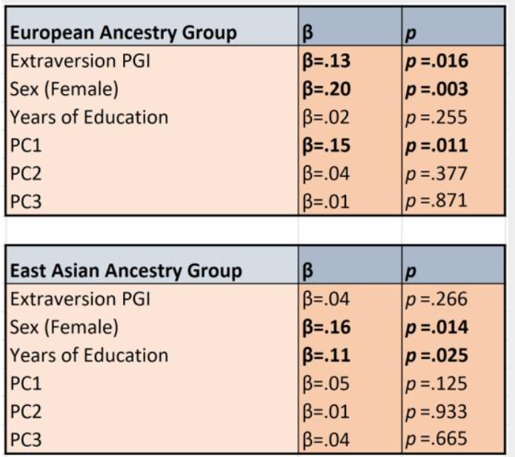
Q7.1: Can the student conclude from these results that genetic influences on language learning are weaker in East Asians? Why or why not?

End of Block: Part 7: Cleanup & Discussion

Start of Block: Bonus section: PCs

Bonus section: Principal components
If you are done with all the previous sections, feel free to dive in here to learn how genetic principal components are made.
These are essentially the first principal components of the genetic relatedness matrix, but we don't have to create the genetic relatedness matrix as a first step. This is handled by default by plink. However, there are a few things we need to be careful about:
- The sample needs to already have been restricted to a single genetic ancestry (in our case, EUR)
- The PC loadings need to be calculated in a sample of unrelated individuals. So if there are related individuals in your sample, you need to exclude them first, obtain PC loadings, and then project the remaining individuals on the PC space.
- We need to exclude long-range high-LD regions. If you don't do this, the first couple of PCs will be dominated by these regions (often consisting of structural variants like inversions, repetitions, etc.)
- Even after excluding long-range LD regions, it's a good idea to do some LD-pruning so that variants with higher LD scores are not overweighted in the PCs.

Let's create a directory for PCs:
mkdir $HOME/PGI_practical/data/processed/PC/

You can obtain a list of long-range LD regions from here:
wget "https://www.dropbox.com/scl/fi/ui2ui736fusf07jb0wkeu/high-LD-regions-hg19-GRCh37.txt?rlkey=uu6knsuvrnm2qu9wbeq9i631v&st=k3u9hxfw&dl=1" -O high-LD-regions-hg19-GRCh37.txt

QPC.1
We start by applying the above mentioned filters, in addition to some other variant-level QC filters to make sure we have a set of good quality variants.(Actually, we already have some nice filtered genotype data lying around that we have used before for clumping which we could use here, but we're going to re-do it here for clarity).

plink2 --pfile $HOME/PGI_practical/data/original/genotypes/all_phase3 \
--keep $HOME/PGI_practical/data/processed/1kG_ph3_EUR.ids \
--king-cutoff 0.025 \
--exclude bed1 $HOME/PGI_practical/data/original/ref_data/high-LD-regions-hg19-GRCh37.txt \
--maf 0.01 \
--geno 0.05 \
--rm-dup force-first \
--set-all-var-ids @:# \
--make-pgen \
--out $HOME/PGI_practical/data/processed/PC/1kG_ph3_EUR_filtered

The only new flag we're using here is --exclude bed1 $HOME/PGI_practical/data/original/ref_data/high-LD-regions-hg19-GRCh37.txt which tells plink to exclude the regions included in the high-LD-regions-hg19-GRCh37.txt file. The bed1 modifier specifies the format the regions are provided in.

How many SNPs are excluded from long-range LD regions? How many individuals are left in the data after the filtering?

QPC.1 Answer: 2496489 variants excluded, 495 individuals left in data.

QPC.2 Now, we are going to do the LD pruning:

plink2 --pfile $HOME/PGI_practical/data/processed/PC/1kG_ph3_EUR_filtered \
--indep-pairwise 1000 5 0.1 \
--out $HOME/PGI_practical/data/processed/PC/1kG_ph3_EUR_filtered_prune

This command does LD-pruning with a rolling window of 1000kb incremented in steps of 5, and a squared correlation cutoff of 0.1. It does not create a new genotype dataset with pruned variants. Instead, it gives you the following two files: $HOME/PGI_practical/data/processed/PC/1kG_ph3_EUR_filtered_prune.prune.in $HOME/PGI_practical/data/processed/PC/1kG_ph3_EUR_filtered_prune.prune.out

The first file contains the variants that survive the pruning, i.e. the variants that we want to keep.

The --extract flag in plink restricts the genotype data to the variants in the file given as argument to the flag. Use this to restrict the 1kG_ph3_EUR_filtered genotype data to the pruned variants. How many variants are left in the data?

QPC.2 Answer: 351448 variants. The command is

plink2 --pfile $HOME/PGI_practical/data/processed/PC/1kG_ph3_EUR_filtered \
--extract $HOME/PGI_practical/data/processed/PC/1kG_ph3_EUR_filtered_prune.prune.in \
--make-pgen \
--out $HOME/PGI_practical/data/processed/PC/1kG_ph3_EUR_filtered_pruned

Making the PCs
Now we will obtain the PC loadings using the filtered genotype data for our sample of unrelated individuals and then project the whole sample onto these PCs. There is a trick to do this in plink2 involving some complicated flags and options:

plink2 --pfile $HOME/PGI_practical/data/processed/PC/1kG_ph3_EUR_filtered_pruned \
--freq counts \
--pca allele-wts vcols=chrom,ref,alt \
--out $HOME/PGI_practical/data/processed/PC/1kG_ph3_EUR_unrelated

plink2 --pfile $HOME/PGI_practical/data/original/genotypes/all_phase3 \
--keep $HOME/PGI_practical/data/processed/1kG_ph3_EUR.ids \
--set-all-var-ids @:# \
--rm-dup force-first \
--read-freq $HOME/PGI_practical/data/processed/PC/1kG_ph3_EUR_unrelated.acount \
--score $HOME/PGI_practical/data/processed/PC/1kG_ph3_EUR_unrelated.eigenvec.allele 2 5 header-read no-mean-imputation variance-standardize \
--score-col-nums 6-15 \
--out $HOME/PGI_practical/data/processed/PC/1kG_ph3_EUR_PCs

The resulting $HOME/PGI_practical/data/processed/PC/1kG_ph3_EUR_PCs.sscore file contains the first 10 PCs.
We use --set-all-var-ids @:# here because we had converted the SNP identifiers in the "1kG_ph3_EUR_filtered_pruned" to this format (Chr:BP) before to deal with missing IDs. Now we have to apply the same flag here so that there is no mismatch between the other input files (the arguments to --read-freq and --score).

Note: The PCs you created here are not going to be identical to the ones you were provided with in the HEIGHT.pheno data because those were created with slightly different parameters but they should be highly correlated.

PCs unrelated sample
This is a rather complicated way to construct PCs but it is necessary when there are related individuals in the sample. If there weren't related individuals, you can skip some of these steps. In that scenario, you would apply all the same SNP-level filters, restrict to EUR-ancestry, but skip the relatedness filter (--king-cutoff). You would then do the pruning, restrict the data to the approximately independent variants (those in the file *.prune.in), and make the PCs by running: plink2 --pfile filtered_pruned_data \
--pca 10 \
--out PCs

End of Block: Bonus section: PCs

Start of Block: The End

The End
Thank you for working through this tutorial. Feel free to go back to any part of the tutorial later on. If you have questions, you can contact me at a.okbay@amsterdamumc.nl

End of Block: The End

